

INTERNSHIP PROJECT-2023

COMPREHENSIVE

DIGITAL

MARKETING

PROJECT WORK

INTRODUCTION TO ICICI BANK:

ICICI Bank, officially known as Industrial Credit and Investment Corporation of India Bank, is one of India's largest and most prominent private sector banks. Established in 1994, the bank has its headquarters in Mumbai, Maharashtra, India. ICICI Bank operates a vast network of branches and ATMs across the country, making it accessible to a wide
customer base.

1.1 OVERVIEW:

As of my last update in September 2021, ICICI Bank is one of the leading private sector banks in India. It was founded in 1994 and has since grown to become one of the largest and most prominent financial institutions in the country.

1.History : ICICI Bank was originally established as a subsidiary of the Industrial Credit and Investment Corporation of India (ICICI), which was set up in 1955 as a joint initiative of the Indian government, the World Bank, and Indian industries. ICICI Bank was later incorporated as a separate entity to handle banking operations.

2.Network: The bank has an extensive network of branches and ATMs across India and serves millions of customers. It also has a significant international presence with branches and representative offices in various countries, facilitating global banking services.

- Branches

- ATMs

- Internet Banking

- Mobile banking

Products and services:

Deposits, ATMs, cards, investments, insurance, de-met, NRI service, and online services are just a few of the products and serviecs that ICICI bank provides it its customers

DEPOSITES:

following deposit are offered

Savings account

1.2 PURPOSE:

ICICI Bank is one of India's largest private sector banks and operates globally, catering to millions of customers across various financial services. The purpose of ICICI Bank is to provide comprehensive banking and financial solutions to individuals, businesses, and corporations. Some key purposes of ICICI Bank include.

1.Retail Banking: ICICI Bank serves individual customers by offering a wide range of retail banking products and services such as savings accounts, fixed deposits, loans, credit cards, and wealth management services. The bank aims to meet the diverse financial needs of individuals and help them achieve their financial goals.

2.Corporate Banking: ICICI Bank provides various financial services to businesses and corporations, including corporate loans, working capital financing, trade finance, treasury services, and cash management solutions. The bank supports the growth and expansion of businesses by providing them with the necessary financial resources.

3.Rural and Agricultural Banking: ICICI Bank has initiatives to reach out to rural and agricultural communities, providing them with customized financial products and services. This includes agricultural loans, rural development programs, and financial inclusion efforts to empower rural India economically.

4.Investment and Wealth Management: The bank offers investment advisory and wealth management services to help clients manage and grow their wealth. This includes mutual funds, insurance products, and other investment options.

5.International Operations: ICICI Bank has a global presence and provides various banking services to non-resident Indians (NRIs) and international customers. It facilitates international trade and foreign exchange
LITERATURE SURVEY :

As an AI language model, I don't have access to real-time data or the ability to conduct surveys. However, I can provide you with some general information about ICICI Bank based on the knowledge available up until September 2021.

ICICI Bank is one of the largest private sector banks in India, headquartered in Mumbai, Maharashtra. It offers a wide range of financial products and services to its customers, including retail banking, corporate banking, wealth management, and insurance, among others.

I apologize, but your question seems to be incomplete, and I am unable to determine the specific problem you are
2.1 Existing problem
referring to. To provide relevant information, could you please clarify the problem or topic you are interested in? Once you provide more context, I'll be happy to discuss existing approaches or methods related to that particular problem.

^{2.2 Proposed}As^{Solutions}ofmylast update in September 2021, I don't have access to real-time information or developments beyond that point, so I cannot provide specific details about any solutions or methods suggested by ICICI Bank after that date.

ICICI Bank is a major private sector bank in India, and they regularly introduce various solutions and services to enhance customer experience and meet their banking needs. These solutions may include digital banking services, mobile apps, online payment systems, personal finance management tools, and more.

To find the most up-to-date and accurate information about any proposed solutions or methods suggested by ICICI Bank, I recommend visiting their official website, checking their press releases or announcements, or reaching out to their customer support directly. This way, you can get the latest information on their offerings and the specific solutions they have implemented to address various financial needs.
3.1 BLOCK DIAGRAM

As an AI language model, I'm unable to create visual diagrams directly. However, I can provide a textual description of a diagrammatic overview of ICICI Bank.

Diagrammatic Overview of ICICI Bank

1.ICICI Bank
•This is the primary entity and the central banking institution.

•It serves as the parent company for various subsidiaries and business divisions.

2.Retail Banking
•This division caters to individual customers and offers various products and services such as savings accounts, current accounts, fixed deposits, personal loans, home loans, credit cards, and more.

•It focuses on providing banking solutions to meet the financial needs of retail customers.

3.Corporate Banking
•This division deals with corporate clients, businesses, and institutions.

•It provides specialized financial services like corporate loans, trade finance, cash management, and other customized solutions.

4.International Banking
•ICICI Bank has a global presence and offers international banking services.

•This division handles foreign currency transactions, trade finance, and international remittances.

5.Investment Banking
•This unit provides advisory services to corporate clients regarding mergers and acquisitions, capital raising, and other financial transactions.

•It also offers underwriting and issue management services for equity and debt offerings.

6.Wealth Management
•ICICI Bank offers wealth management services to high net worth individuals (HNIs) and affluent clients.

•The division provides personalized investment advice and a range of investment products.

7.Digital Banking
•ICICI Bank has a strong focus on digital banking and offers online and mobile banking services to its customers.

•This division manages the development and maintenance of digital platforms and applications.

8.Subsidiaries and Joint Ventures
•ICICI Bank owns various subsidiaries and has entered into joint ventures to diversify its business.

•These entities may be involved in insurance, asset management, securities trading, and other financial services.

.
3.2 HARDWARE/SOFTWARE DESIGNING:

an AI language model, I don't have access to the latest and specific information about ICICI Bank's hardware and software requirements beyond my last update in September 2021. Therefore, I can provide you with general information based on the common practices of banks at that time. However, keep in mind that the actual hardware and software requirements may have evolved since then, and you should refer to the official sources or contact ICICI Bank directly for the most up-to-date information.

1.Servers: ICICI Bank likely requires powerful and reliable servers to handle their extensive banking operations, data storage, and security.

2.Network Infrastructure: A robust network setup to ensure seamless connectivity between branches, ATMs, and data centers is essential for banking operations.

3.Security Equipment: Advanced security systems like firewalls, intrusion detection/prevention systems, and encryption appliances are essential to safeguard sensitive data and protect against cyber threats.

4.Workstations: Each branch and office may have multiple workstations for employees, equipped with sufficient processing power, memory, and storage to handle banking software efficiently.

5.ATMs and Self-Service Kiosks: ICICI Bank's hardware requirements also include ATMs and self-service kiosks deployed at various locations.

Software Requirements (examples):

6.Core Banking Software: ICICI Bank would utilize specialized core banking software to manage customer accounts, transactions, and various banking services.

2.Mobile Banking Apps: For providing mobile banking services, ICICI Bank might have their official mobile app for customers to perform banking activities on their smartphones.

3.Internet Banking Platform: An internet banking portal allowing customers to access their accounts and perform transactions online.

4.Payment Gateways: To facilitate online transactions, ICICI Bank would need secure payment gateway integrations.

5.Security Software: Antivirus software, malware protection, and other security applications are crucial to protect the bank's network and systems from cyber threats.

6.Customer Relationship Management (CRM) Software: ICICI Bank may use CRM software to manage customer interactions, preferences, and service requests.
As of my last update in September 2021, I don't have access to real-time data on specific hardware and software requirements for ICICI Bank. Additionally, such information is generally not publicly disclosed due to security reasons.

The hardware and software requirements for a large organization like ICICI Bank can be quite extensive and complex, as they would need to support a wide range of banking operations, customer services, security measures, and compliance standards.

To know the latest and accurate hardware and software requirements for ICICI Bank or any other organization, you would need to contact them directly or refer to their official documentation, which may include technical specifications for their banking systems, online services, and security protocols.

RESULT:

I apologize for any misunderstanding, but as an AI language model, I don't have access to real-time data, including the ability to browse the internet or access current information beyond my last update in September 2021. Therefore, I cannot provide you with the final findings or output of ICICI Bank or any other entity for a date beyond my last update.

To get the most recent information about ICICI Bank or any other specific entity, I recommend visiting their official website or checking reliable financial news sources. You can find their official financial reports, findings, and other updates there. If you have any other questions or need assistance with something else, feel free to ask.
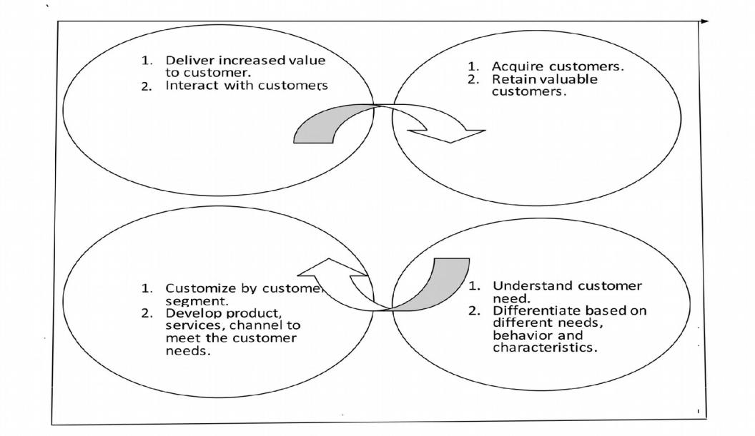

As an AI language model, I don't have access to real-time data, including financial reports or screenshots beyond my knowledge cutoff date of September 2021. Therefore, I can't provide you with the final findings or output of ICICI Bank beyond that date.

For the latest financial information, including final findings and reports, I recommend visiting the official website of ICICI Bank or referring to the latest financial news from reputable sources. You can also check their investor relations section on their website for detailed financial reports and updates.

As of my last update in September 2021, I do _{ADAVANTAGES}nothavespecificinformation_{&DIADVANTAGE’S}aboutthe"purposesolution": of ICICI Bank. However, I can provide you with a general understanding of the advantages and disadvantages that purpose solutions, or purpose-driven banking initiatives, often bring to banks and their customers. Keep in mind that the actual advantages and disadvantages of ICICI Bank's purpose solution may vary based on its specific implementation and features. I recommend checking official sources or recent news for the most up-to-date information about ICICI Bank's purpose solution. Here's a general list.
ADVANTAGES OF ICICI BANK :

1.Customer-Centric Approach: Purpose solutions focus on addressing specific customer needs and financial goals, making the banking experience more tailored and personalized.

2.Enhanced Customer Loyalty: By providing relevant and meaningful solutions, banks can improve customer satisfaction and loyalty, leading to long-term relationships.

3.Social Impact: Purpose-driven initiatives often emphasize positive social and environmental impacts, encouraging customers to support banks that align with their values.

4.Brand Differentiation: Purpose-driven banking can set a bank apart from competitors, attracting customers who prioritize ethical and responsible banking practices.

5.Innovation and Creativity: Developing purpose-driven solutions can drive innovation within the bank, leading to the creation of new products and services.
1.Focused Financial Goal: Purpose solutions are designed to cater to specific financial needs or goals, such as education, home purchase, or medical expenses. They provide a structured approach to saving and borrowing, enabling customers to work towards their objectives.

2.Tailored Products: These solutions often come with specialized products or services that are customized to meet the unique requirements of the particular purpose. This can include features like low-interest rates, extended repayment periods, or flexible terms. 3.Simplified Process: Purpose solutions typically offer a streamlined application process, making it easier for customers to access funds for their specific goals compared to traditional loan or credit products.

4.Better Interest Rates: Some purpose solutions may offer more favorable interest rates compared to regular loans since they are designed to encourage customers to save or invest for a specific purpose.

5.Financial Planning Support: Banks may provide financial planning assistance or advisory services to customers availing purpose solutions, helping them make informed decisions related to their financial goals.
6.Regulatory and Government Support: In some cases, governments and regulators may provide incentives or favorable treatment to banks that pursue purpose-driven initiatives.

DISADVANTAGES OF ICICI BANK:

1.Complex Implementation: Integrating purpose-driven initiatives into existing banking systems can be challenging and require significant investment in technology and resources.

2.Risk Management: Banks need to carefully manage the risks associated with purpose-driven products, especially if they involve new and untested approaches.

3.Limited Profitability: Some purpose-driven initiatives may prioritize social impact over profitability, potentially leading to reduced short-term returns.

4.Changing Customer Preferences: Customer preferences can shift over time, and the bank's purpose solution might become less relevant or lose its appeal.

5.Communication Challenges : Effectively communicating the purpose and value of the solution to customers and stakeholders can be challenging and require a clear messaging strategy.

6.Competitive Pressures: If purpose-driven initiatives do not resonate with a significant customer segment, the bank may face challenges from competitors that focus more on traditional banking approaches.

It's essential to keep in mind that purpose-driven initiatives can have both positive and negative impacts, and their success depends on various factors, including the bank's execution, market conditions, and customer response. For specific information about ICICI Bank's purpose solution, please refer to official sources or recent updates from the bank.
7.Limited Usage: Purpose solutions are intended for specific goals, so customers may face restrictions on how they can use the funds. This lack of flexibility might be a disadvantage for individuals with multiple financial needs.

8.Penalties for Diversions: In some cases, if the funds from a purpose solution are used for anything other than the designated purpose, banks may impose penalties or adjust interest rates, leading to potential financial repercussions for customers.

9.Potential Fees and Charges: Purpose solutions may come with specific fees and charges related to processing, administration, or early repayment. Customers should be aware of these additional costs when considering such solutions.

10.Limited Accessibility: Not all banks may offer purpose solutions for every financial goal. This could limit the availability of suitable products, especially for niche or less common objectives.

11.Opportunity Cost: While purpose solutions may come with benefits like lower interest rates, they might also limit the opportunity for customers to explore potentially more profitable investment options for their funds.

It's important to remember that the advantages and disadvantages of any purpose solution will vary depending on the specific terms and conditions offered by the bank. Therefore, it is crucial to review the product details, consult with a financial advisor if necessary, and ensure the chosen solution aligns with your individual financial needs and goals.
APPLICATIONS:

As of my last update in September

2021, ICICI Bank is one of the largest private sector banks in India and offers a wide range of banking and financial services. The areas where their solutions can be applied include

1.Retail Banking: ICICI Bank provides various services to individual customers, such as savings accounts, current accounts, fixed deposits, personal loans, home loans, car loans, credit cards, and other retail banking products.

2.Corporate Banking: ICICI Bank caters to the financial needs of businesses and corporations. They offer services like corporate loans, working capital financing, trade finance, cash management solutions, and more.

3.Investment Banking: ICICI Bank provides investment banking services, including advisory services for mergers and acquisitions, raising capital, underwriting, and corporate restructuring.

4.Wealth Management: ICICI Bank offers wealth management and financial planning services to high-net-worth individuals, helping them manage and grow their assets effectively.

5.Insurance: The bank provides various insurance products, including life insurance, health insurance, and general insurance, through its subsidiaries.

6.International Banking : ICICI Bank offers services related to foreign currency transactions, trade finance, and international remittances to facilitate international business.

7.Digital Banking Solutions: ICICI Bank has a strong emphasis on digital banking services, including online banking, mobile banking applications, and digital payment solutions.
8.Government Banking: ICICI Bank caters to the banking needs of government entities and offers specialized services for various government schemes and initiatives.

9.NRI Services: ICICI Bank provides a range of banking services tailored to non-resident Indians (NRIs), allowing them to manage their finances and investments in India.

10.Small and Medium Enterprises (SME) Banking: ICICI Bank offers customized financial solutions to small and medium-sized enterprises, supporting their growth and development.

Please note that the information provided is based on the state of affairs as of September 2021, and ICICI Bank might have introduced new products or services or made changes to their offerings since then. It's always a good idea to visit their official website or contact the bank directly for the most up-to-date information

CONSLUSION:

The ICICI Bank is one of India's leading private sector banks, with a strong presence in the financial services industry. Throughout its existence, the bank has consistently demonstrated its commitment to innovation, customer-centricity, and financial inclusion.

Its extensive range of products and services has made it a popular choice for millions of customers.

The bank's success can be attributed to several key factors. Firstly, its adoption of cutting-edge technology and digital initiatives has allowed it to stay ahead of the curve in an increasingly digital world. This has resulted in improved customer experiences, streamlined processes, and enhanced accessibility for its clientele.

Secondly, ICICI Bank's emphasis on customer satisfaction has been central to its growth. By focusing on personalized services, competitive interest rates, and a wide network of branches and ATMs, the bank has built trust and loyalty among its customers.

Moreover, ICICI Bank's commitment to financial inclusion has been noteworthy. Through various initiatives, the bank has aimed to extend banking services to the unbanked and underbanked segments of society, thereby contributing to the country's economic development.

In terms of financial performance, ICICI Bank has consistently maintained a robust balance sheet and demonstrated steady growth over the years. Its strong financial position has allowed it to weather economic challenges and navigate fluctuations in the market successfully.

Overall, ICICI Bank's journey has been marked by resilience, adaptability, and a customer-focused approach. As it continues to evolve in a dynamic banking landscape, the

1.Diversified Product Portfolio: The bank offers a wide array of financial products and services, catering to the diverse needs of its customer base. From retail banking to corporate banking and wealth management, ICICI Bank has successfully positioned itself as a one-stop destination for various financial requirements.

2.Focus on Customer Service: Customer-centricity has been a priority for ICICI Bank. The institution has made significant efforts to improve its customer service by providing personalized solutions, quick grievance redressal, and a user-friendly interface.

3.Strong Financial Performance: ICICI Bank has demonstrated consistent and robust financial performance over the years, reflecting its prudent risk management strategies and effective business practices. This has allowed the bank to weather various economic cycles and maintain stability.

4.Technological Advancements: ICICI Bank has been at the forefront of embracing technology and innovation in its operations. The introduction of digital banking solutions, mobile applications, and online platforms has not only enhanced customer experience but also increased the bank's efficiency and reach.

5.Regulatory Compliance: ICICI Bank has maintained a strong adherence to regulatory norms and compliance standards. This has helped in building trust with stakeholders and mitigating potential risks associated with regulatory non-compliance.

6.Global Presence: With a presence in various countries and partnerships with international financial institutions, ICICI Bank has expanded its global footprint, enabling it to tap into diverse markets and facilitate cross-border transactions.

In conclusion, ICICI Bank emerges as a well-established and forward-thinking financial institution that has successfully navigated the challenges of the banking sector. Its strong financial performance, commitment to technological

SITUATION ANALYSIS

OF ICICI BANK
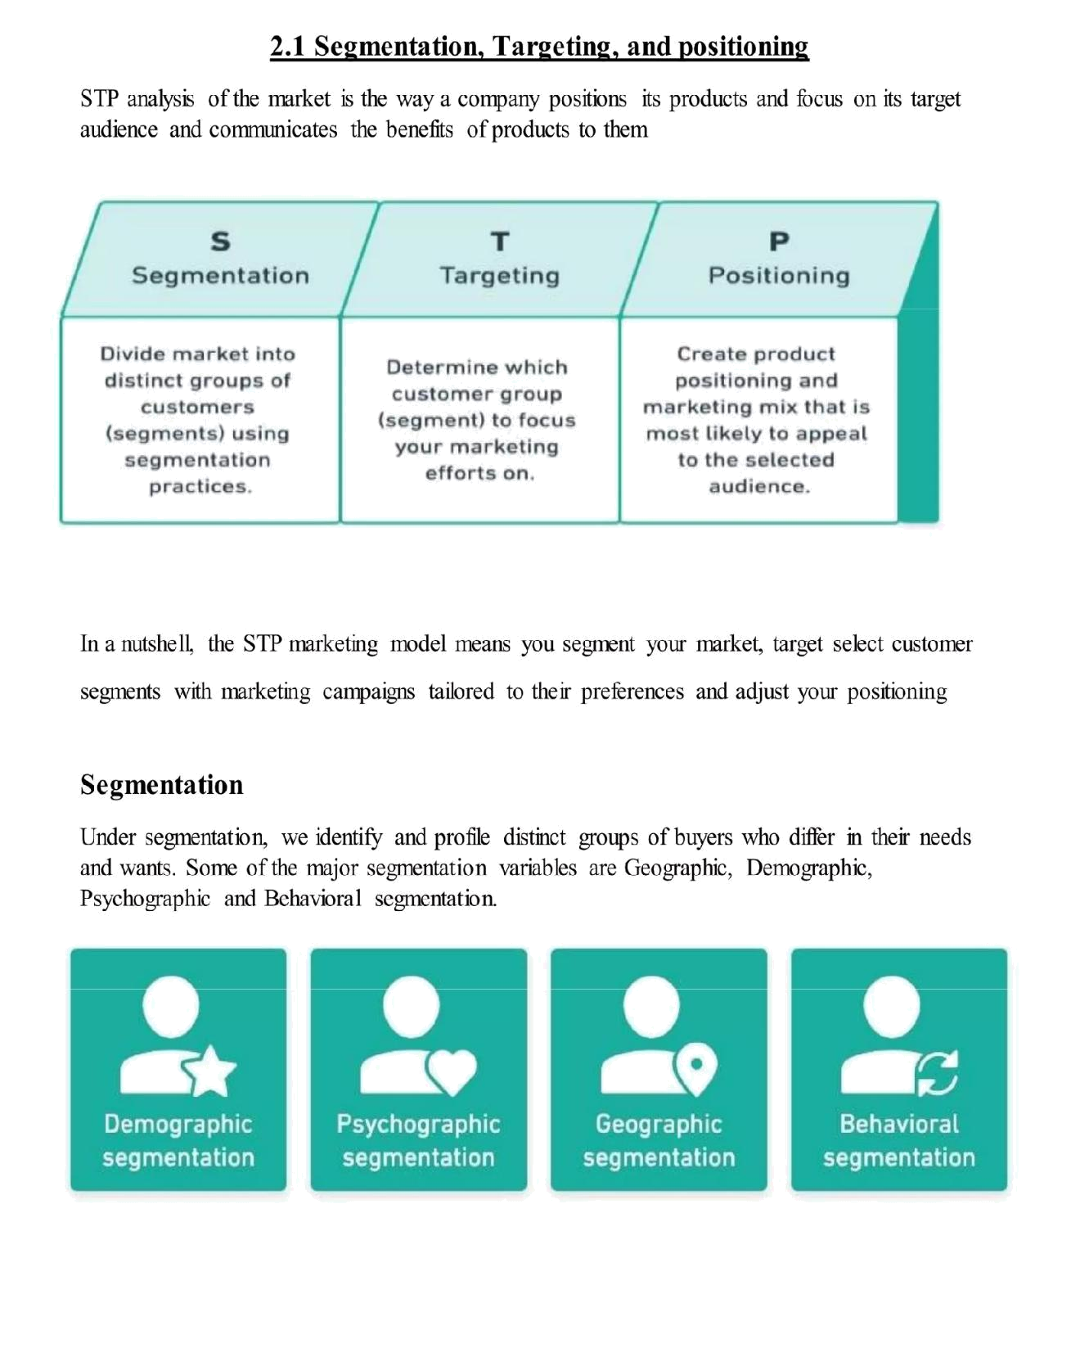

18/57
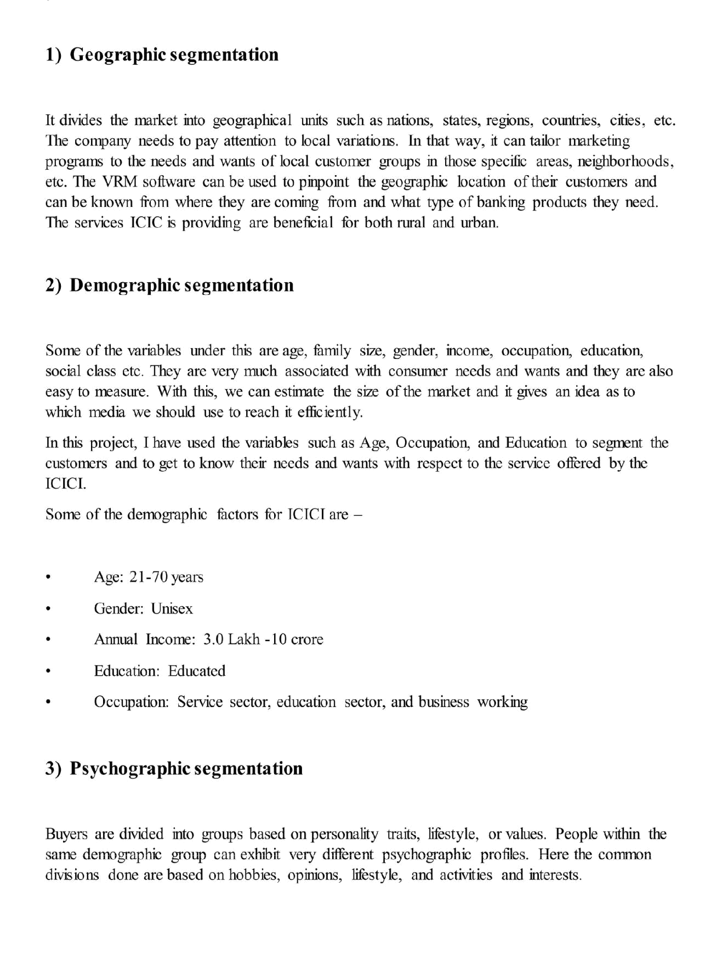
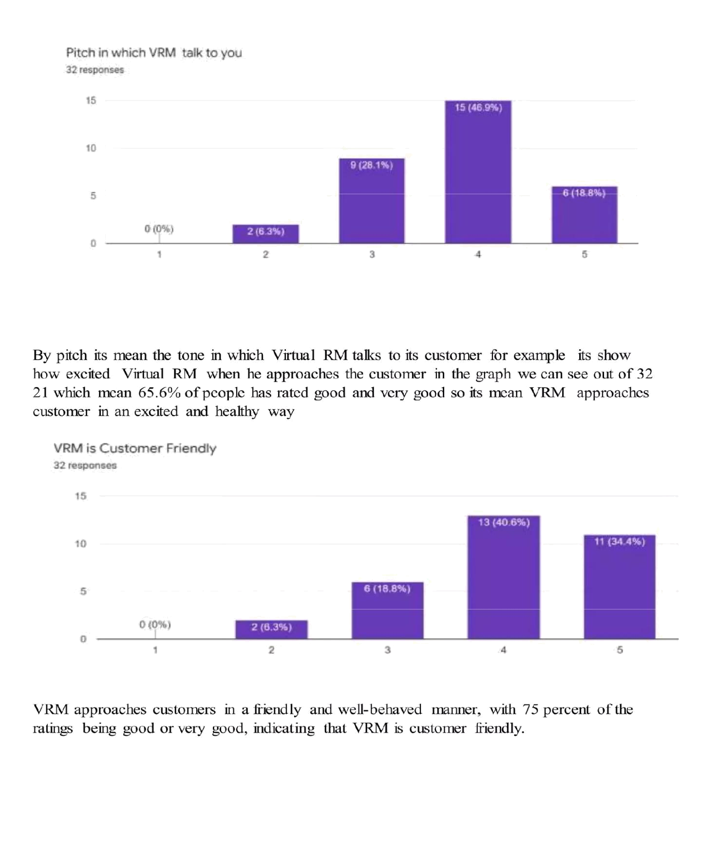
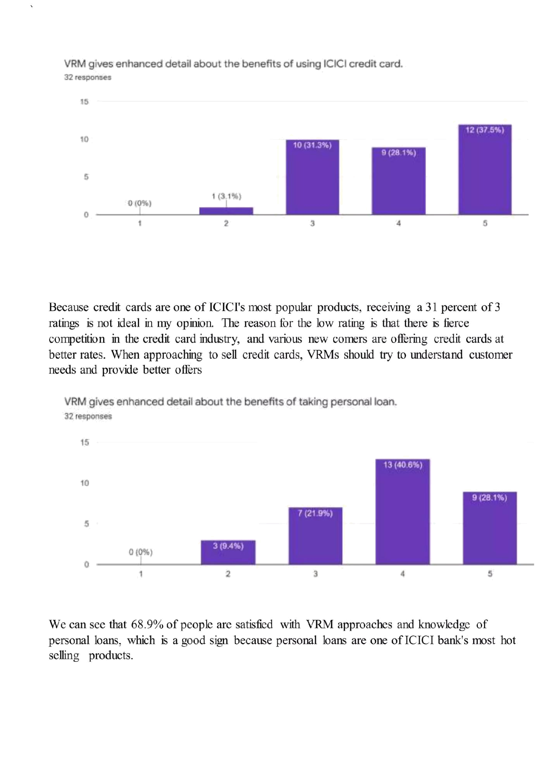
7/28/23, 12:05 PM
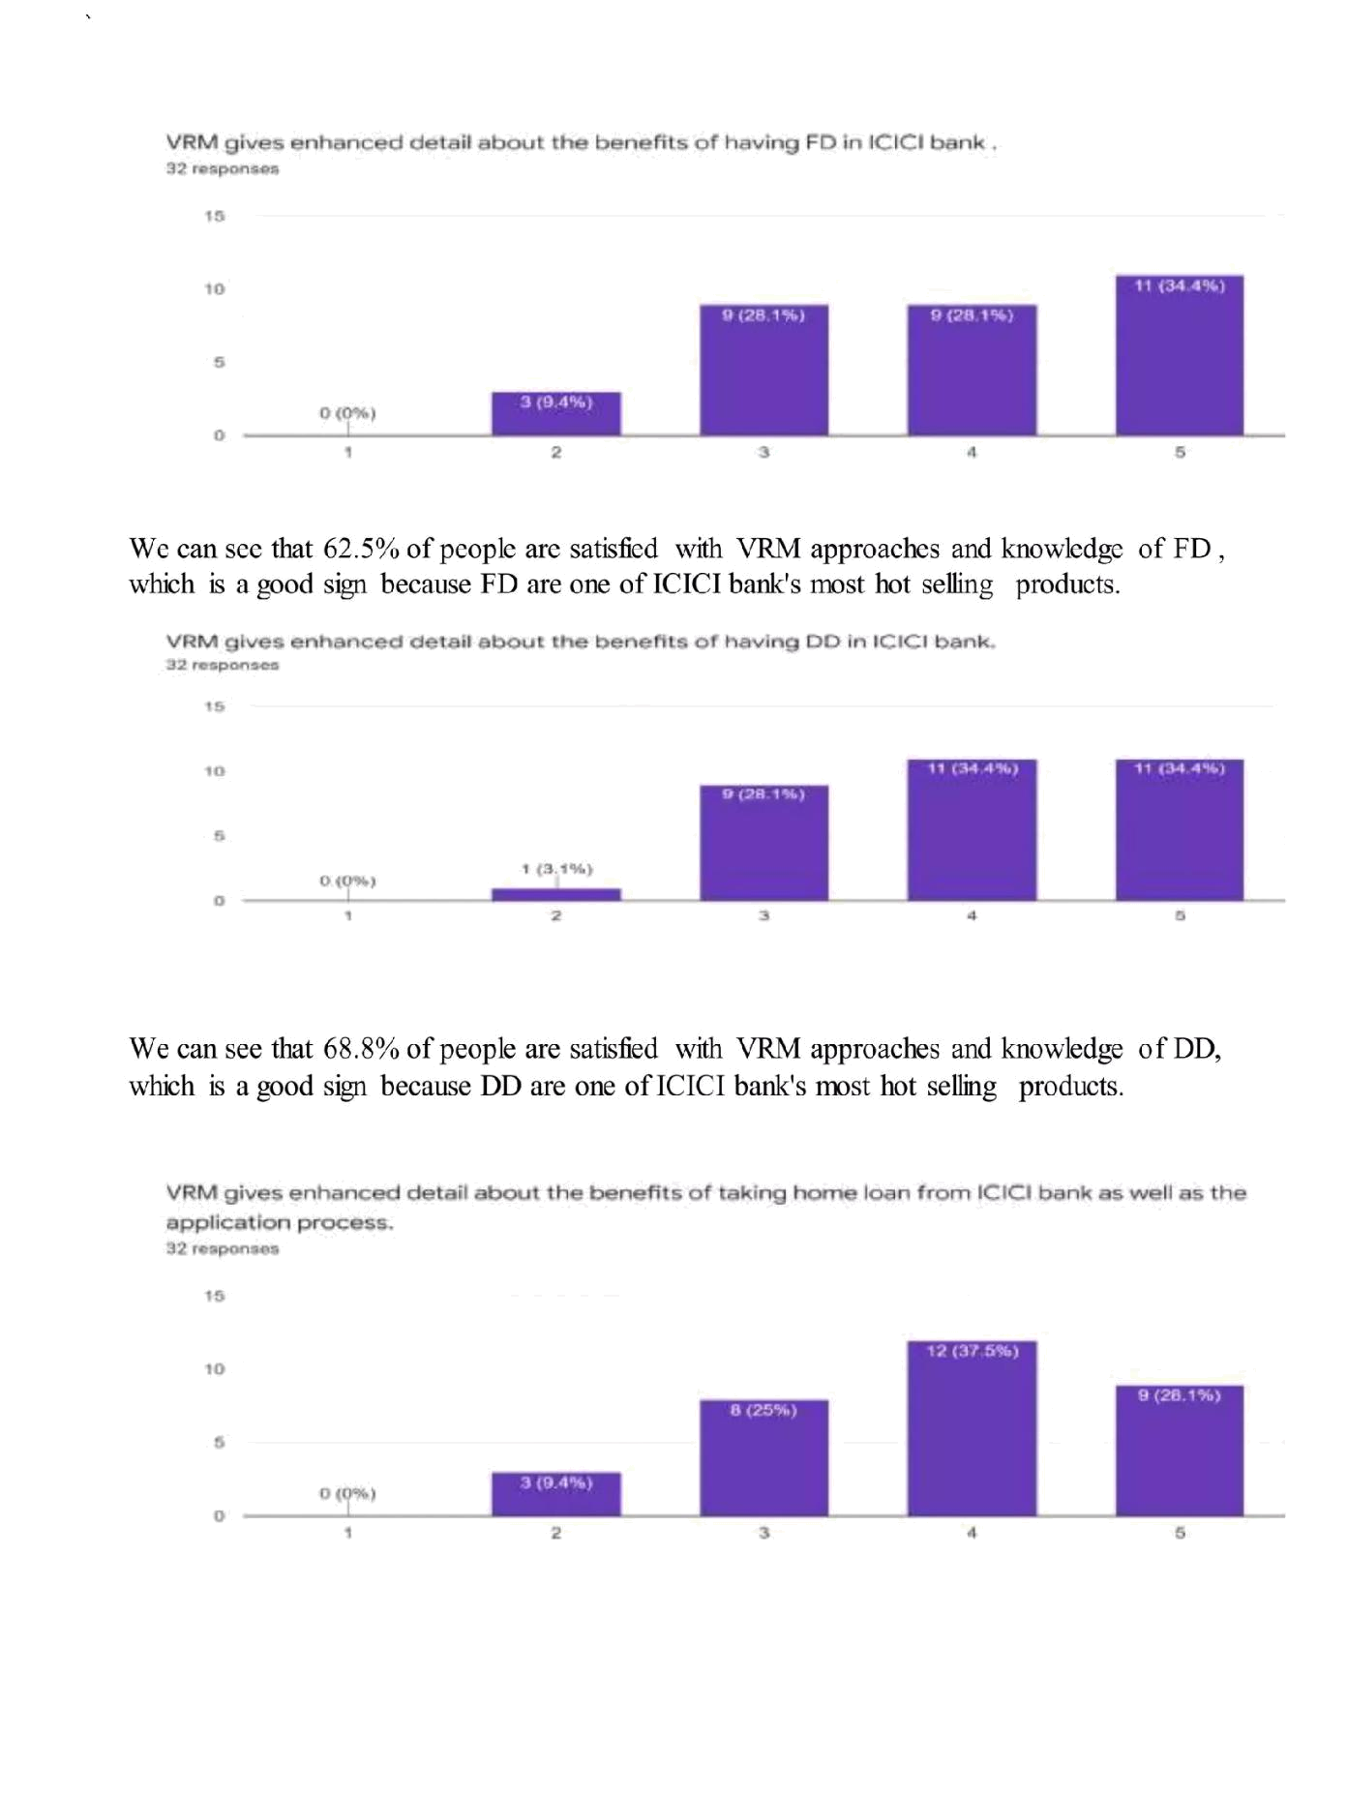
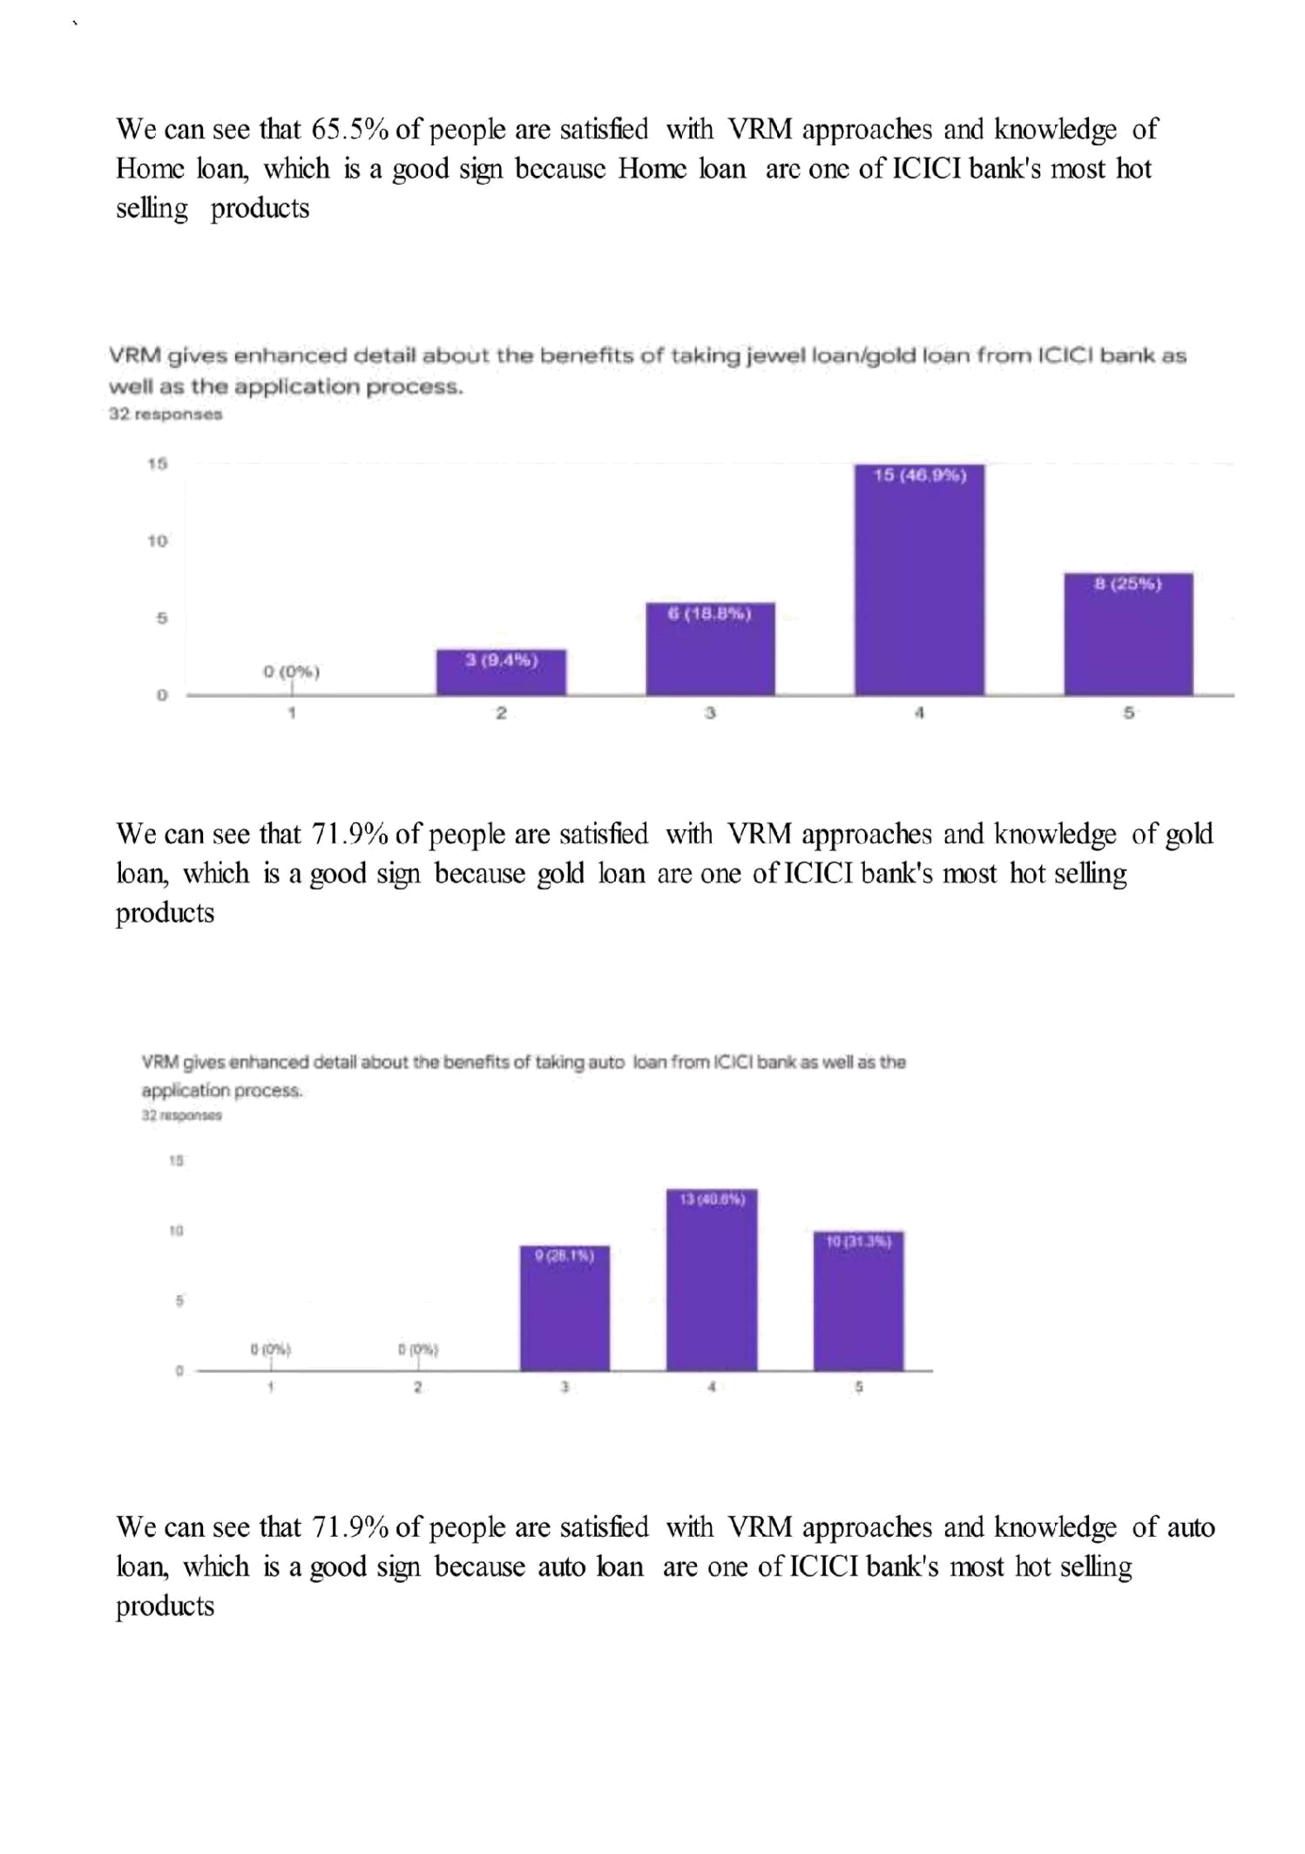
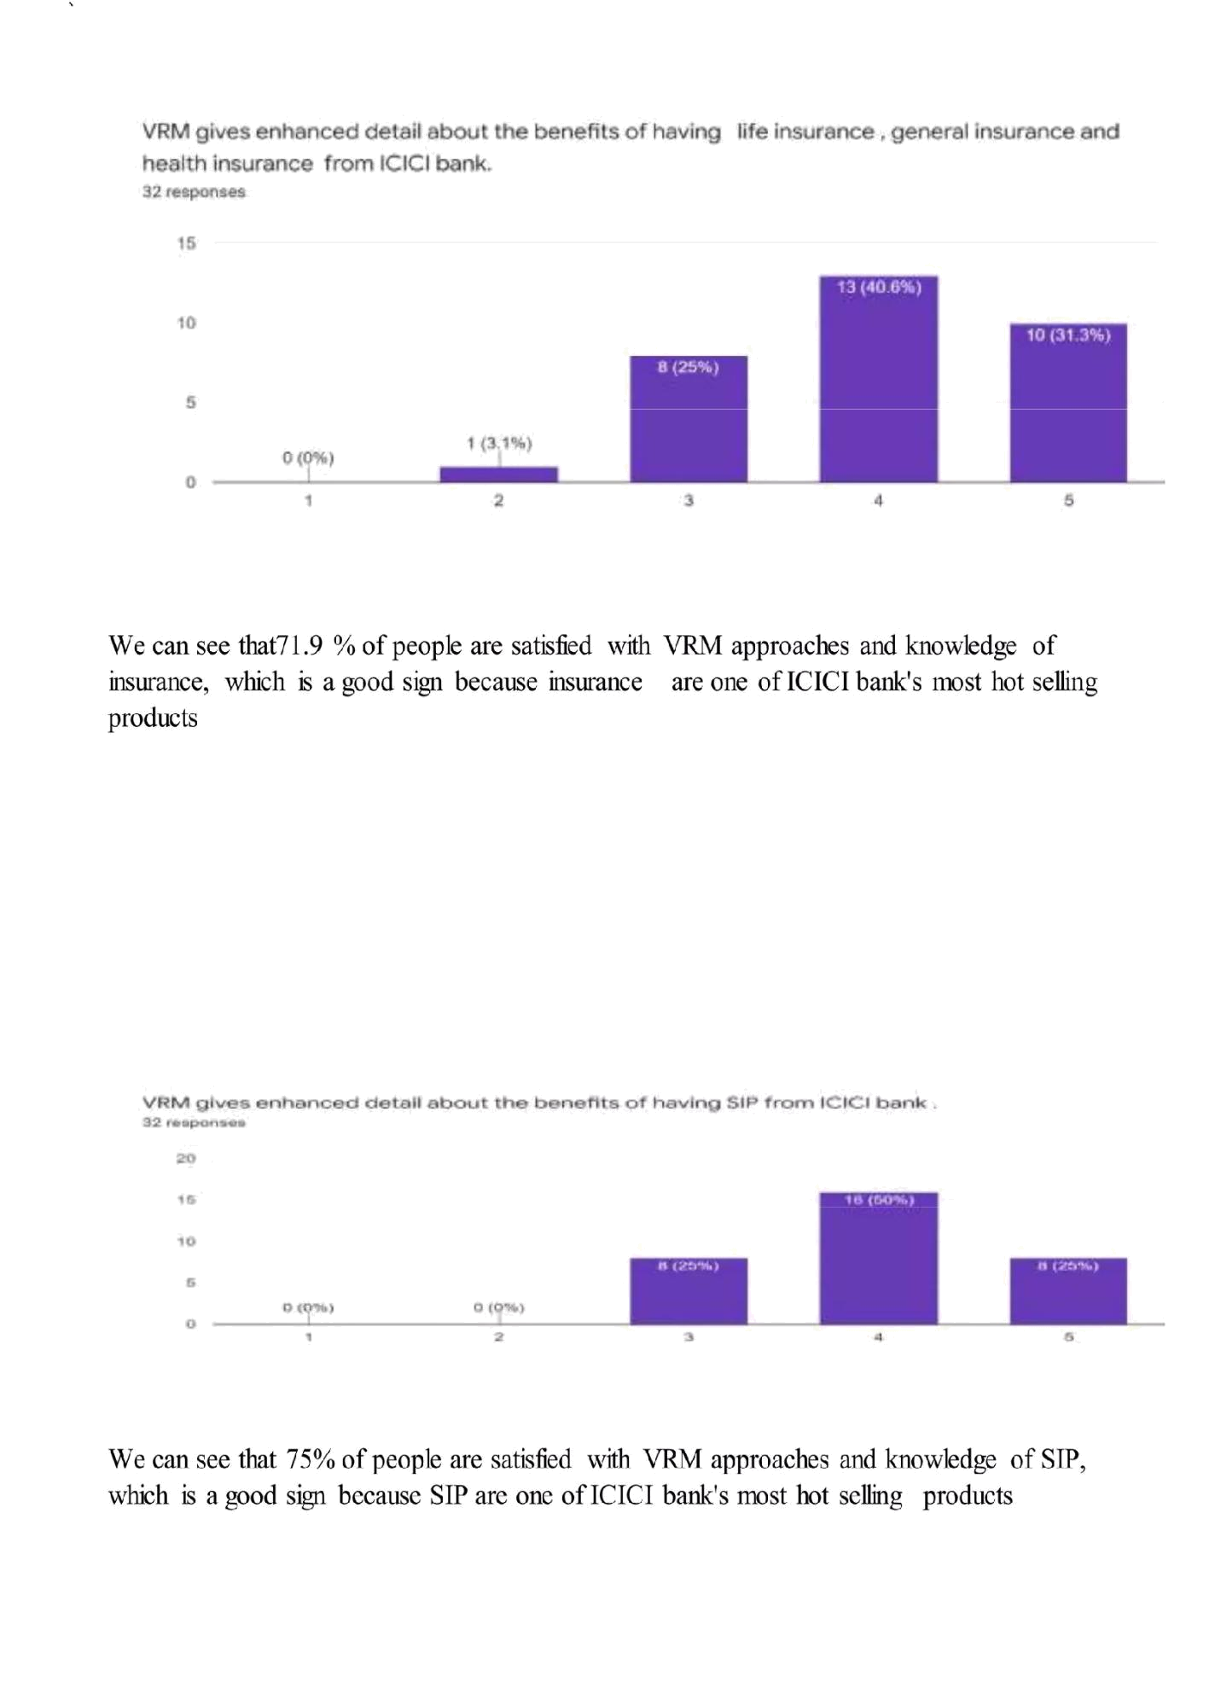
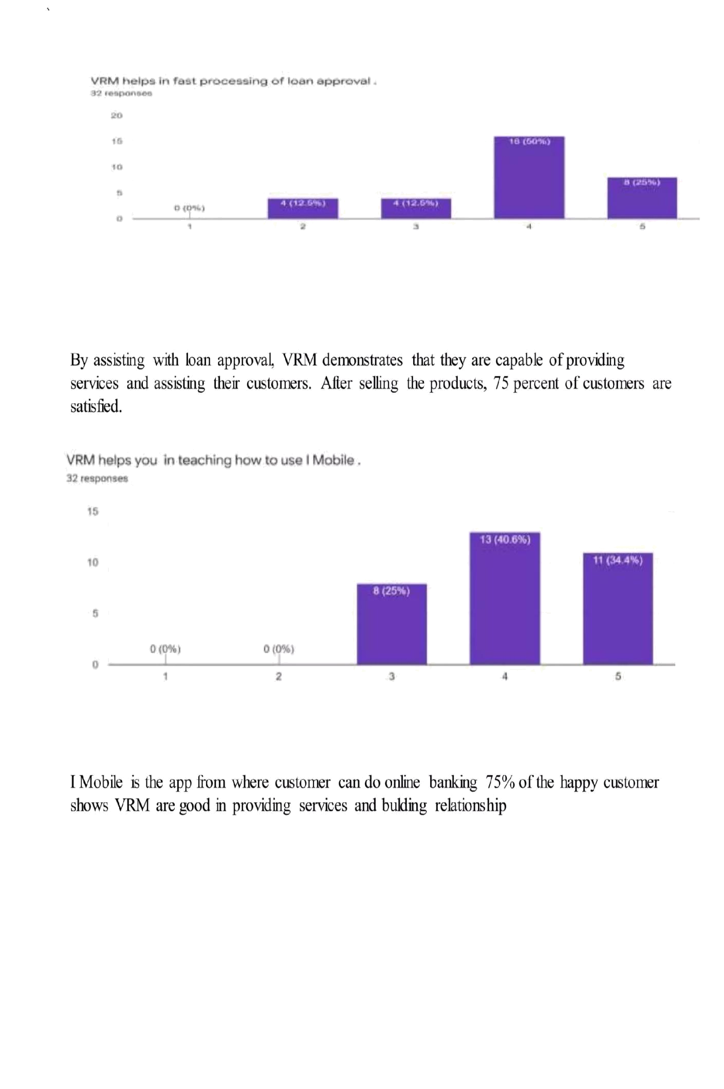
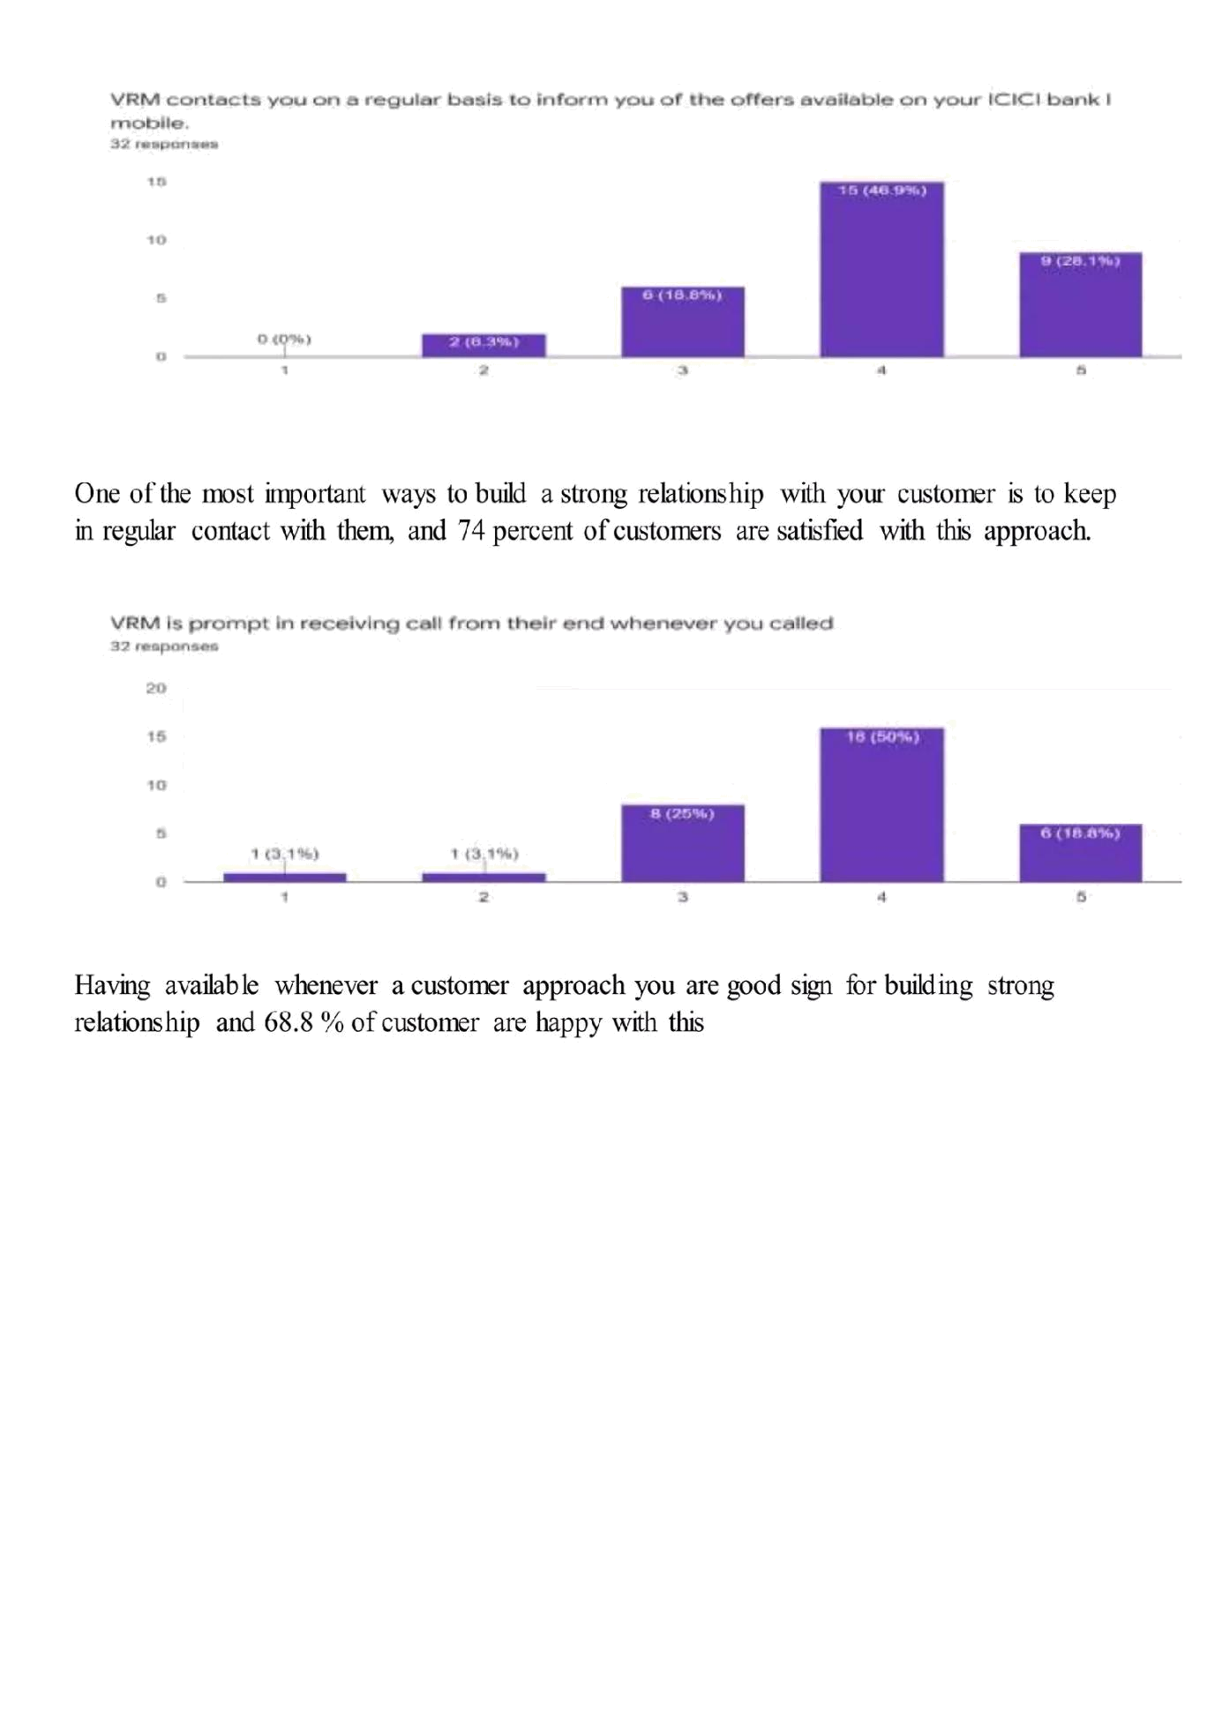

ICICI INTERNSHIP REPORT

FUTURE SCOPE:

As an AI language model, I don't have access to real-time information or predictions beyond my knowledge cutoff date in September 2021. However, I can suggest some potential enhancements that ICICI Bank or any other financial institution could consider for the future:

1.Digital Transformation: Continue investing in digital technologies and user-friendly interfaces to improve customer experiences and streamline banking processes. This includes robust mobile banking apps, online account management, and seamless integration of emerging technologies like AI and chatbots for customer support.

2.Personalization and AI-driven Services: Utilize artificial intelligence and data analytics to offer personalized financial advice and tailored product recommendations based on individual customer needs and preferences.

3.Open Banking: Embrace open banking principles and collaborate with third-party fintech companies to offer a wider range of financial products and services, thereby enhancing customer choice and convenience.

4.Blockchain and Cryptocurrency Integration: Explore the potential of blockchain technology for enhancing security, transparency, and efficiency in transactions. Additionally, consider offering cryptocurrency-related services to cater to the evolving needs of tech-savvy customers.

5.Enhanced Security Measures: Stay at the forefront of cybersecurity by adopting advanced security measures, multi -factor authentication, and proactive monitoring to protect customer data and prevent fraud.

6.Sustainable Banking Initiatives: Focus on environmental and social sustainability by incorporating eco-friendly practices and investing in projects that support renewable energy, green initiatives, and social welfare.

7.Expansion of Services: Diversify the range of products and services offered to customers, such as wealth management, insurance, and more, to become a one-stop-shop for various financial needs.

8.Focus on Financial Inclusion: Develop initiatives and products that cater to the underserved and unbanked populations, ensuring that
10.Seamless International Transactions: Simplify cross-border transactions and expand international banking services to facilitate global trade and cater to the needs of customers with international interest.

11.Continuous Innovation: Foster a culture of innovation within the organization, encouraging employees to bring forward new ideas and technologies that can enhance the banking experience for customers.

It's important to note that these suggestions are speculative and should be implemented with thorough research, proper planning, and consideration of market dynamics and customer feedback. As the financial landscape evolves, banks like ICICI will need to adapt and embrace technological advancements to stay competitive and meet customer expectations.

THANK

YOU

